**Test**

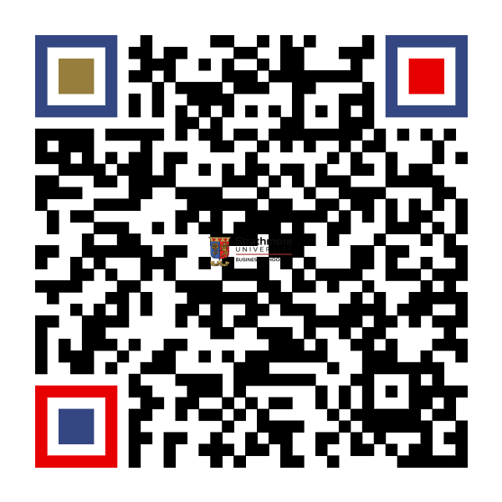

Test Venue

2023-02-18, 12:53 - 14:53